Module Code | IY4113
Group | B
Module Title | Practical assignment part 1: Java Fundamentals
Assessment Type | Report
Module Tutor Name | Jonathan Shore
Student ID Number | P460817
Assessment Window | Final submission: 16/02/2026- 22/02/2026

☒ I confirm that this assignment is my own work. Where I have referred to academic sources, I have provided in-text citations and included the sources in the final reference list.

☒ Where I have used AI, I have cited and referenced appropriately.

Introduction
This report presents the design, development and evaluation of the CityRide Lite application, developed as the final stage of the IY4113 module. The system is a console-based Java application that allows users to record public transport journeys, calculate fares, remove journeys and generate daily summaries.
The application enables users to add journeys using validated input, calculate fares based on predefined fare rules, apply passenger-type discounts and apply a daily cap during summary calculation. Journeys are stored in memory for the duration of the program session. The system also allows users to list all recorded journeys and remove journeys by their unique ID.
The objective of this project was to demonstrate an understanding of Java fundamentals, object-oriented programming, control structures, input validation and data handling using collections.

Analysis
The CityRide Lite system was designed to satisfy the functional requirements of the assignment. The application operates through a continuously running main menu, allowing the user to select different features until the exit option is chosen.
The system provides the following core functionality:
Add a journey
Remove a journey by ID
List all journeys
Generate a daily summary
Exit the application
Fare Calculation
Fare calculation is based on predefined zone rules within the FareCalculator class.
The base fare is determined by the selected zone:
Zone 1: £2.50
Zone 2: £3.20
Zone 3: £4.00
If the time band is Peak, an additional £0.50 is added to the base fare.
Passenger-type discounts are applied as follows:
Adult: 0%
Child: 50%
Student: 20%
Senior: 30%
The final fare is calculated by applying the relevant discount to the adjusted base fare.
Daily Cap Logic
A daily cap is applied during summary calculation. The cap is determined by the highest zone travelled on that day:
Zone 1 cap: £7.00
Zone 2 cap: £8.50
Zone 3 cap: £10.00
If the total cost of journeys for a given date exceeds the cap, the total is reduced to the cap value.

Data Management
Journeys are stored in an ArrayList within the JourneyManager class. Each journey is assigned a unique session ID, incremented automatically. Data is stored in memory only and is cleared when the application terminates.
Input validation ensures that invalid menu selections and non-existing journey IDs are handled safely. The program prevents unexpected crashes by validating user input before processing.

Input–Process–Output (IPO) Table
Add Journey
Input | Process | Output
Date entered by user | Validate date input | Valid date stored
Zone (1–3) | Validate numeric and range (1–3) | Valid zone stored
Passenger type (Adult, Child, Student, Senior) | Validate passenger type | Valid passenger type stored
Time band (Peak/OffPeak) | Validate time band | Valid time band stored
Zone | Retrieve base fare (Zone 1 £2.50, Zone 2 £3.20, Zone 3 £4.00) | Base fare
Time band | If Peak, add £0.50 surcharge | Adjusted fare
Passenger type | Apply discount (Child 50%, Student 20%, Senior 30%) | Final fare
Generated ID | Assign unique journey ID | Journey ID
All validated data | Create Journey object | Journey stored in ArrayList
Successful operation | Display confirmation message | “Journey added successfully”

Remove Journey
Input (Source) | Process | Output
User enters Journey ID | Check if ID is numeric | Error OR continue
Stored journey list | Search for matching ID | Found OR not found
Found ID | Remove journey from list | Journey removed
Updated journey list | Reset running totals | Totals cleared
Each remaining journey | Recalculate discounted fare | Updated totals
Each remaining journey | Reapply cap logic | Updated charged fares
Completed recalculation | Display success message | “Journey removed successfully”
List Journey
Input (Source) | Process | Output
User selects “List Journeys” from main menu | Validate menu selection | Continue to list function
Stored journey list (in memory) | Check if journey list is empty | If empty → “No journeys recorded” message
Stored journey list | Initialise iteration counter | Prepare loop
Each Journey object | Retrieve journey ID
Each Journey object | Retrieve journey date
Each Journey object | Retrieve fromZone value
Each Journey object | Retrieve toZone value
Each Journey object | Retrieve zonesCrossed value
Each Journey object | Retrieve timeBand
Each Journey object | Retrieve passengerType
Each Journey object | Retrieve baseFare
Each Journey object | Retrieve discountedFare
Each Journey object | Retrieve chargedFare
Retrieved values | Format monetary values to 2 decimal places
Retrieved values | Format output string for display
Completed iteration | Display all journey records in order entered | Formatted journey list

Filter Journey
Inputs | Processing | Outputs
Menu option (Filter Journeys) | Display filter menu options | Filter menu shown
Filter type selection (Passenger Type / Time Band / Zone / Date) | Validate filter selection | Error message if invalid selection
Passenger Type (if selected) | Validate passenger type against enum values | Error message if invalid
Time Band (if selected) | Validate peak/off-peak input | Error message if invalid
Zone number (if selected) | Validate zone is between 1–5 | Error message if invalid
Date (if selected) | Validate date format not blank | Error message if invalid
Stored journey list (ArrayList<Journey>) | Loop through journey list | Filtered journey list
 | Compare each journey’s attribute with filter criteria | Matching journeys identified
 | If no match found → detect empty result | “No journeys found” message
 | Format output values (2 decimal places for fares) | Display filtered journeys

Daily Summary
Input | Process | Output
Date entered by user | Filter journeys by matching date | Matching journeys
Matching journeys | Sum total fares | Total cost
Matching journeys | Count total journeys | Journey count
Total cost | Determine highest zone travelled that day | Cap threshold identified
Total cost | Apply daily cap (Zone 1 £7.00, Zone 2 £8.50, Zone 3 £10.00) | Capped total
Total cost and count | Calculate average cost | Average fare
Calculated results | Display summary report | Daily summary output

Totals by passenger type
Inputs (Source) | Processing Steps | Outputs
Menu option (View Totals by Passenger Type) | Validate menu selection | Totals screen displayed
Stored journey list (ArrayList<Journey>) | Check if list is empty | “No journeys recorded” message if empty
Stored journey list | Group journeys by passenger type | Passenger groups created
Journey.passengerType | Count journeys per passenger type | Journey count
Journey.baseFare | Sum base fares per passenger type | Pre-discount total
Journey.discountedFare | Sum discounted fares per passenger type | Discounted total
Journey.chargedFare | Sum charged fares per passenger type | Charged total
Dataset DAILY_CAP value | Retrieve cap for passenger type | Cap value
Charged total | Compare charged total with cap | Cap reached (Yes/No)
Calculated totals | Format monetary values (2 decimal places) | Formatted output
All calculated values | Display results per passenger type | Structured totals report

Processing Breakdown (Step-by-Step)
User selects “View Totals by Passenger Type”
System checks if journey list is empty → If empty, display message and return
For each passenger type (Adult, Student, Child, Senior):
Count total journeys
Sum baseFare values
Sum discountedFare values
Sum chargedFare values
Retrieve daily cap from dataset
Compare charged total with cap
Determine if cap reached
Format values to 2 decimal places
Display results clearly grouped by passenger type
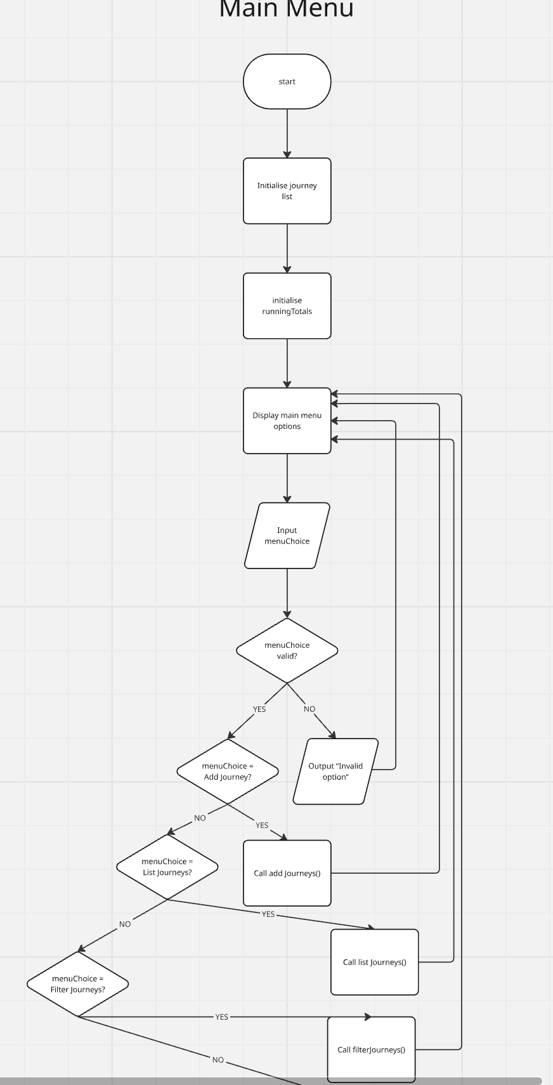
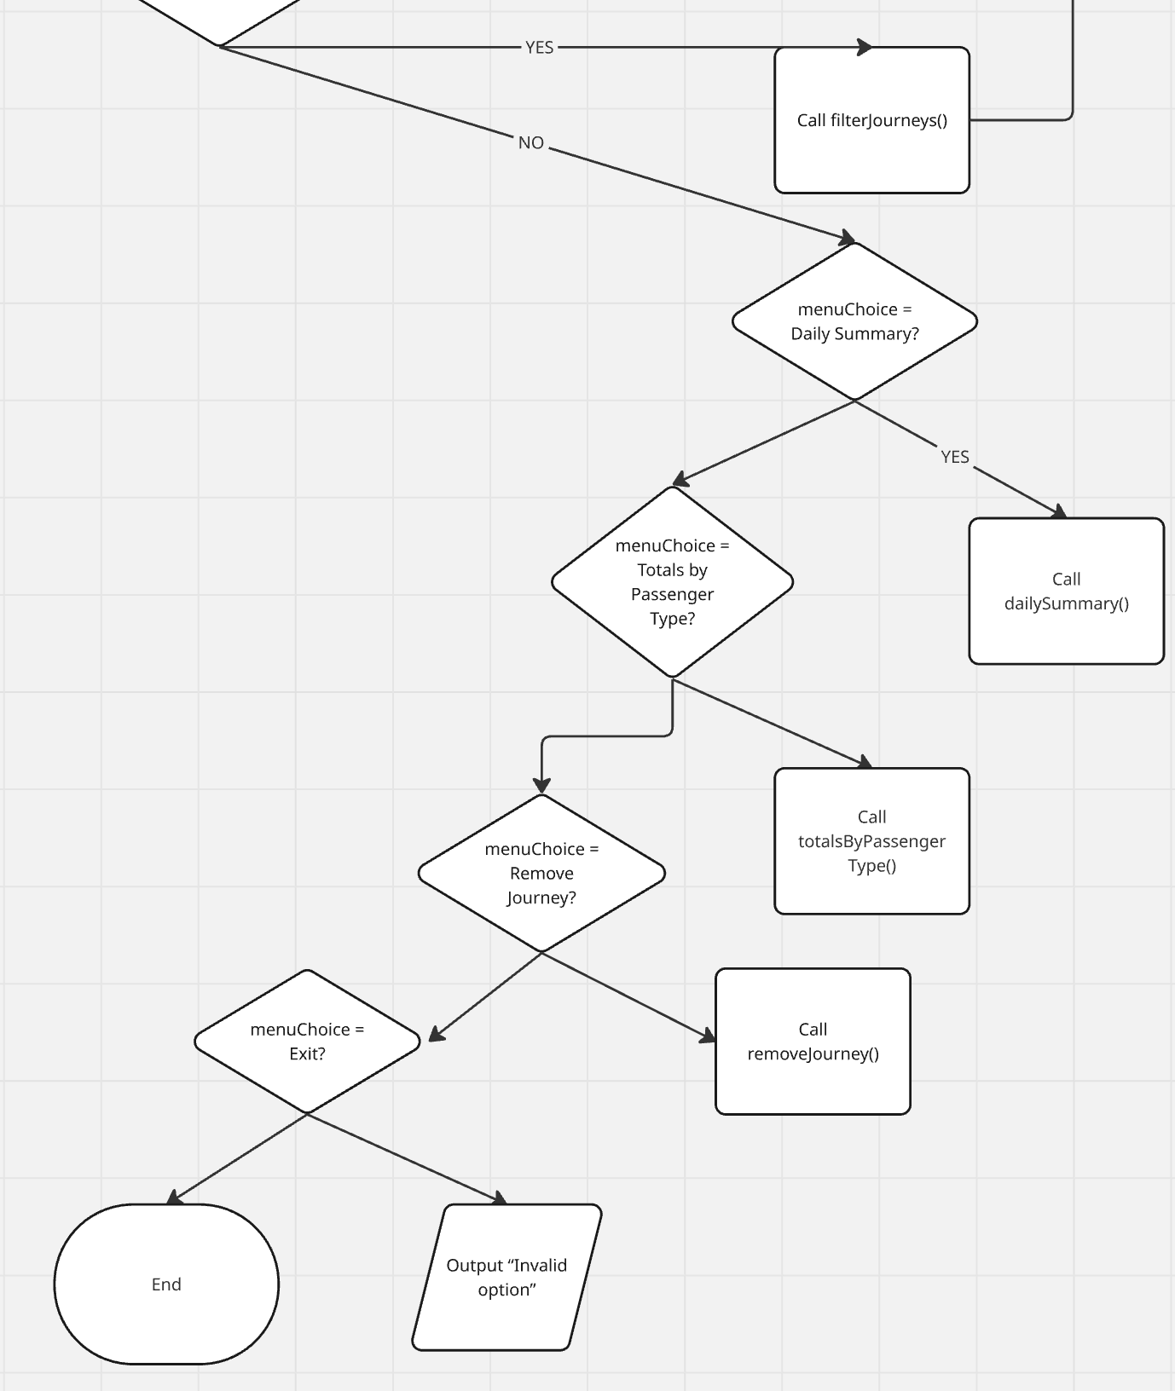

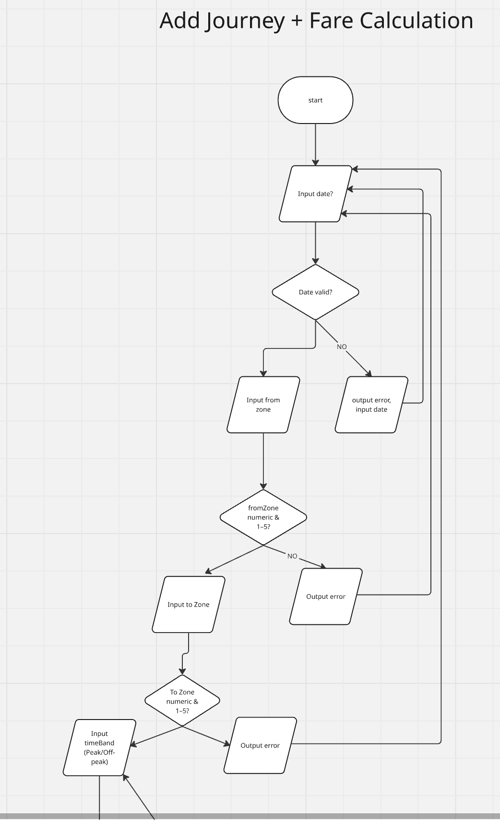
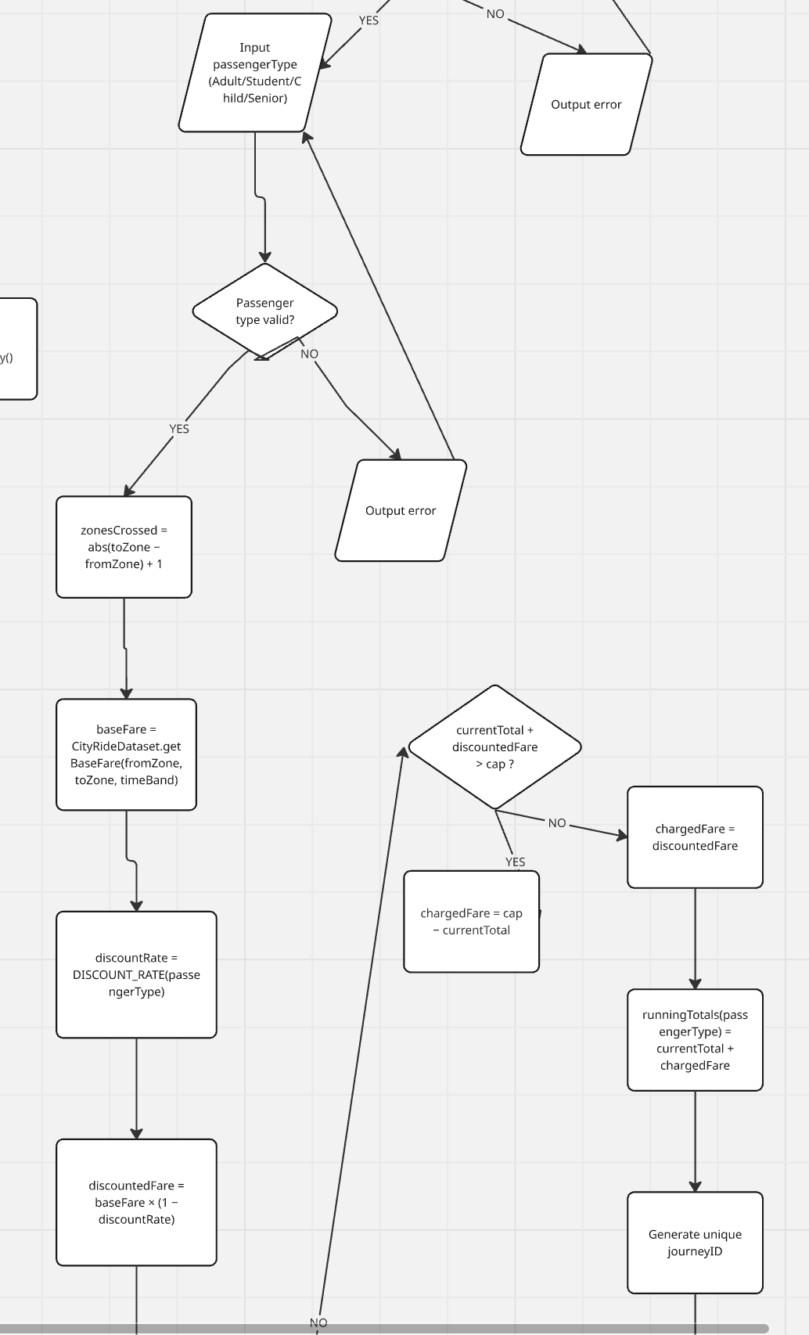
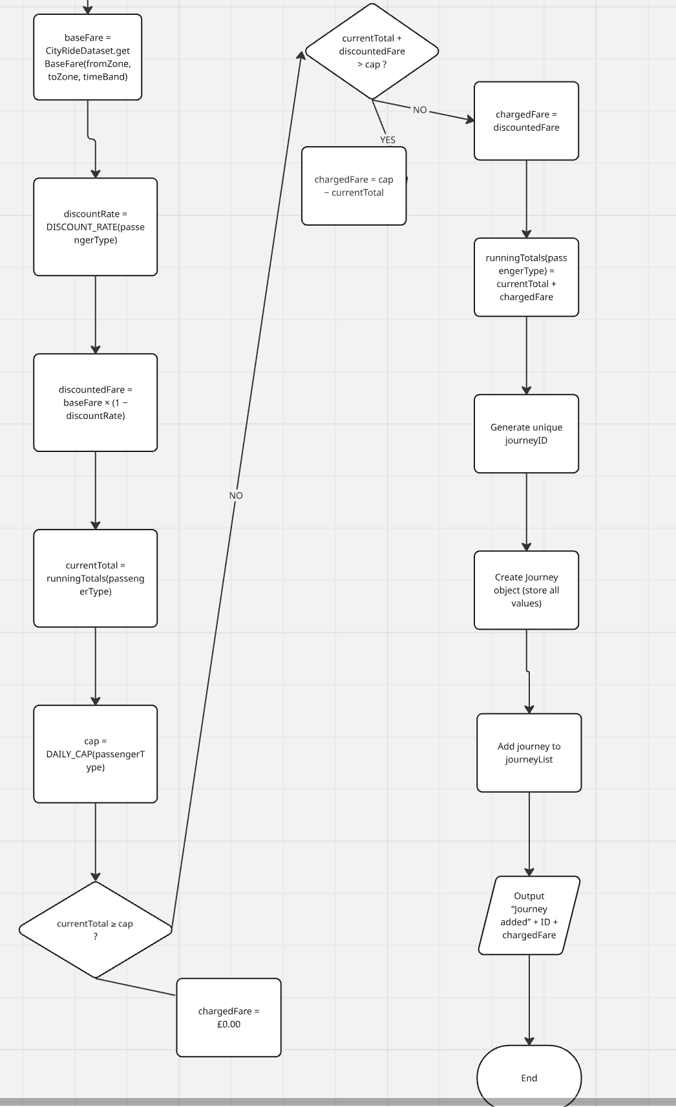
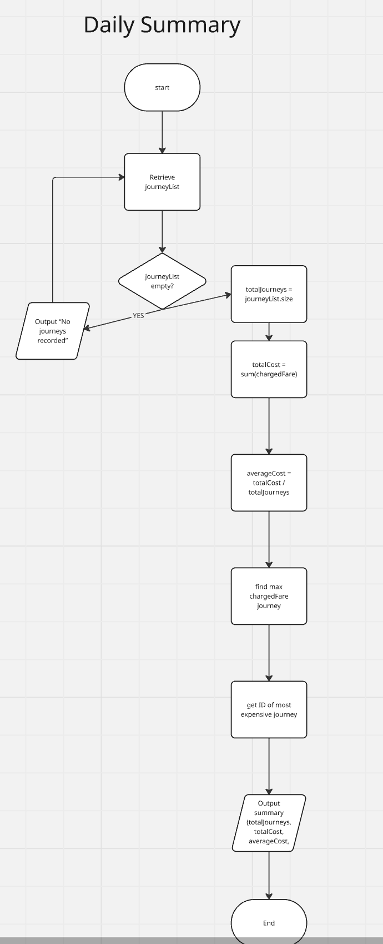

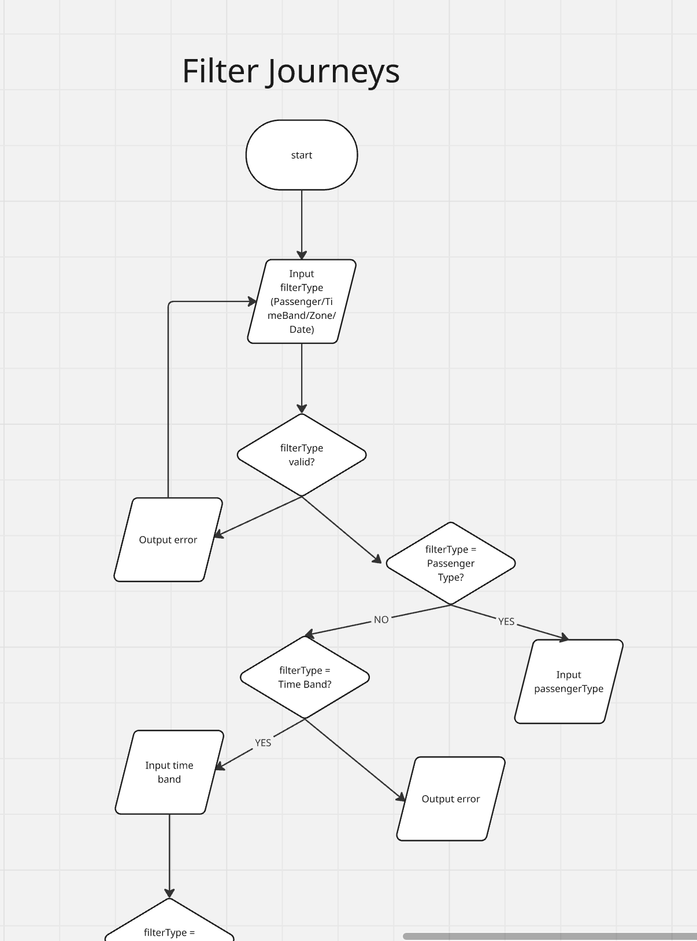

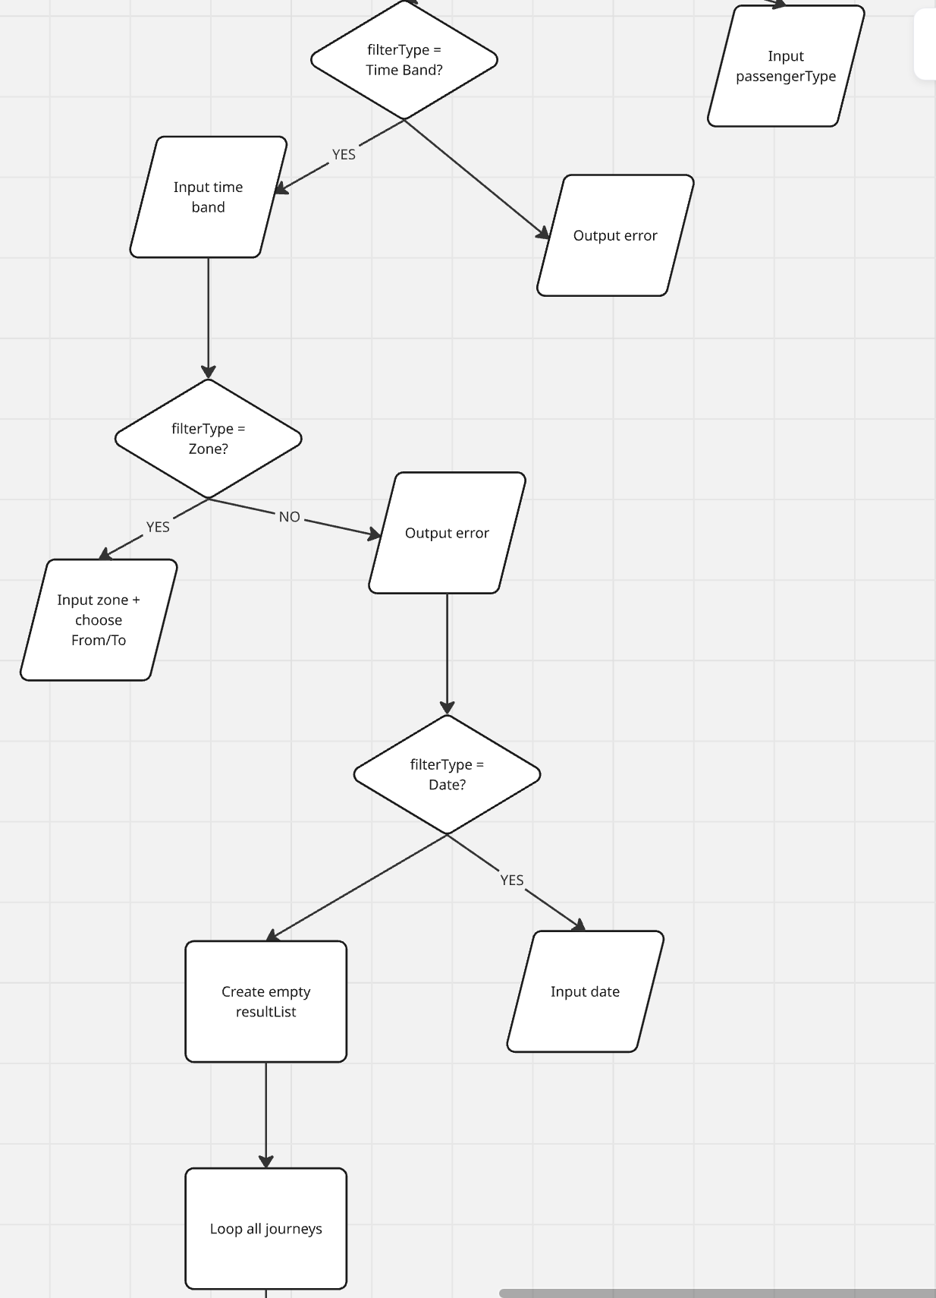

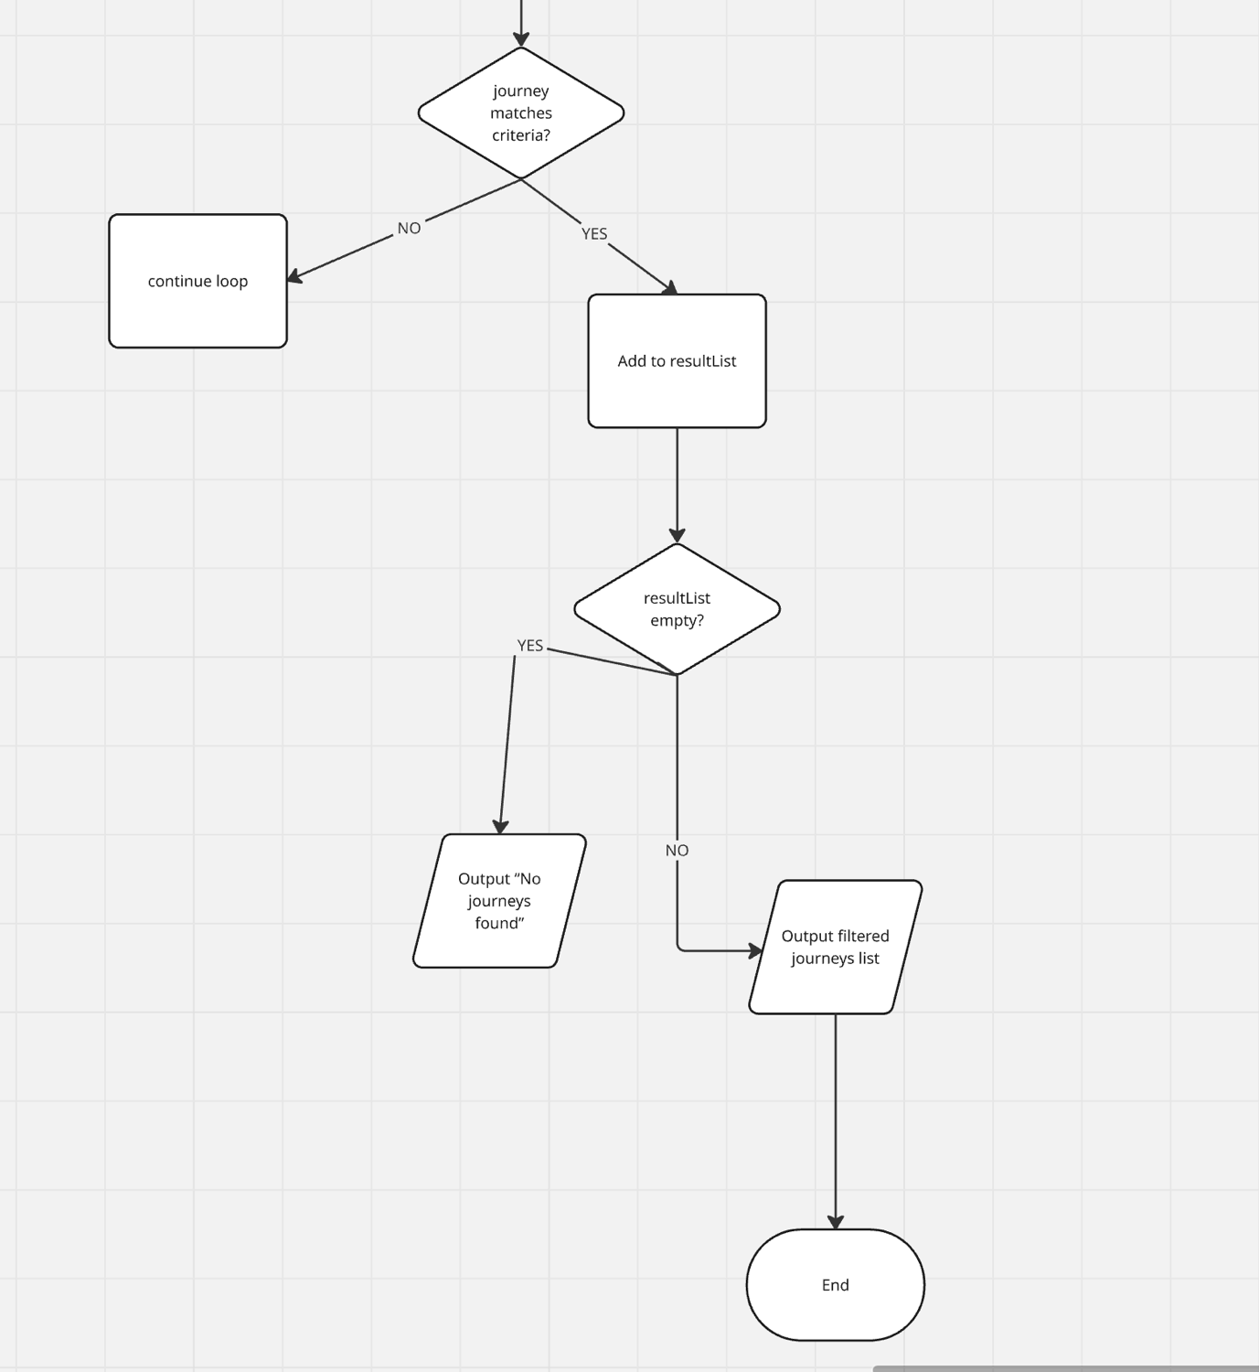

Testing
The system was tested using manual black-box testing. Each feature was tested using valid, invalid and boundary input values to ensure correct functionality and error handling.
Test Case ID | Feature | Input | Expected Result | Actual Result | Status
TC1 | Add Journey | Date: 01/02/2026, Zone:1, Adult, Peak | Fare = £3.00, ID assigned | Fare = £3.00, ID = 1 | PASS
TC2 | Add Journey (Discount) | Zone:2, Child, OffPeak | Fare = £1.60 | Fare = £1.60 | PASS
TC3 | Invalid Menu | Choice: 9 | “Invalid choice!” message | Correct error displayed | PASS
TC4 | Daily Summary | Date: 01/02/2026 | Total=£4.60, Avg=£2.30 | Correct values displayed | PASS
TC5 | Remove Valid ID | ID: 1 | Journey removed | Removed successfully | PASS
TC6 | Remove Invalid ID | ID: 999 | “Journey ID not found” | Correct message displayed | PASS
TC7 | Daily Cap Test | 3× Zone1 Peak Adult | Total capped at £7.00 | £7.00 displayed | PASS

EVALUATION
The CityRide Lite project demonstrates a solid understanding of Java fundamentals and object-oriented programming principles. The system is structured into multiple classes, each with a clearly defined responsibility. This separation improves readability, maintainability and logical organisation.
The use of collections allows dynamic storage of journey data within a session. The unique ID mechanism ensures that journeys can be accurately identified and removed. Input validation enhances reliability by preventing invalid data from causing system failures.
Fare calculation logic correctly applies base fares, peak adjustments and passenger discounts. The daily cap mechanism ensures that the total cost does not exceed predefined thresholds, demonstrating conditional logic and control flow implementation.
However, the system has certain limitations. Data is stored only in memory and is lost when the program exits. A future improvement would be implementing file handling or database storage to allow persistent data management. Additionally, the user interface is console-based and could be enhanced with a graphical user interface for improved usability.
Further improvements could include:
Persistent file storage
Use of enumerations for stronger validation
Expanded reporting features
More advanced statistical analysis
Overall, the system successfully meets the functional requirements and demonstrates competence in Java programming, control structures, collections and modular design.

REFERENCES

Oracle (2024) Java Platform, Standard Edition Documentation. Available at: https://docs.oracle.com/javase/
Moovit Ltd. (2026) Moovit Mobility Management Platform and Urban Transit Solutions. Available at: https://moovit.com
Kaplan International Pathways. (2026). IY4113 Practical Assignment Part 1: Java Fundamentals – CityRide Lite Specification. Nottingham Trent University.
OpenAI. (2026). ChatGPT (GPT-5). Used for structural guidance, report formatting and explanation of programming concepts. Available at: https://openai.com/

APPENDICES
Appendix A – CityRideLiteApp.java
Appendix B – Journey.java
Appendix C – FareCalculator.java
Appendix D – JourneyManager.java
Appendix E – DailySummary.java

